Decentralized Social Media

Now-a-days almost all peoples are using Social Media sites to post their opinion, political reviews, product reviews and many more but this social media applications are dependent on centralized (single server) servers to store and process data and if this sever hack then all users data will leak and if crash due to overloaded requests then services will be down.

To overcome from this problem author is proposing concept to migrate centralized social media to decentralized social media by using Blockchain technology. Blockchain maintain data at multiple nodes or servers and if one server down then user can avail services from other working nodes and Blockchain support immutable data storage which means data cannot be alter or leaked as Blockchain store each record as transaction/block and associate each block with unique code called hash code hence make a chain of blocks with data and hash code. Before storing any new record Blockchain will verify hash code of all previous block and if any block data alter then different hash code will be generated and verification will be failed so it’s not possible to hack or alter Blockchain server.

To store data in Blockchain we need to build Solidity contract which exposes functions to store and retrieve data. This Solidity contract will be deployed on Ethereum tool and after deployment Ethereum will return deployed contract address and by using that address we can access the contract using any programming language such as ‘Java’ and ‘Python’.

In this paper author is using social media application such as posting and viewing tweets as this is based on decentralized Blockchain so author named it as dtweets. By using this Blockchain technique fraud peoples cannot post their advertisements and cannot post fake tweets etc. In propose paper author is saying Blockchain will provide rewards to user if its account is blocked but in this training Blockchain we don’t have reward functions so I am building tweeter based application using Blockchain.

Below screen showing Solidity Blockchain Contract code

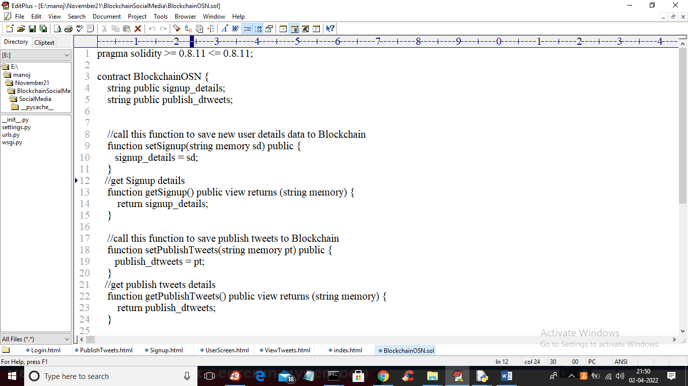

Above screen solidity code contains two functions where one function will store user signup details and other function will store user publish tweets. To deploy above contract on Ethereum we need to follow below steps

1. First go inside “hello-eth/node_modules/.bin’ folder and then double click on ‘runBlockchain.bat’ file to start Blockchain server and to get below screen
2. 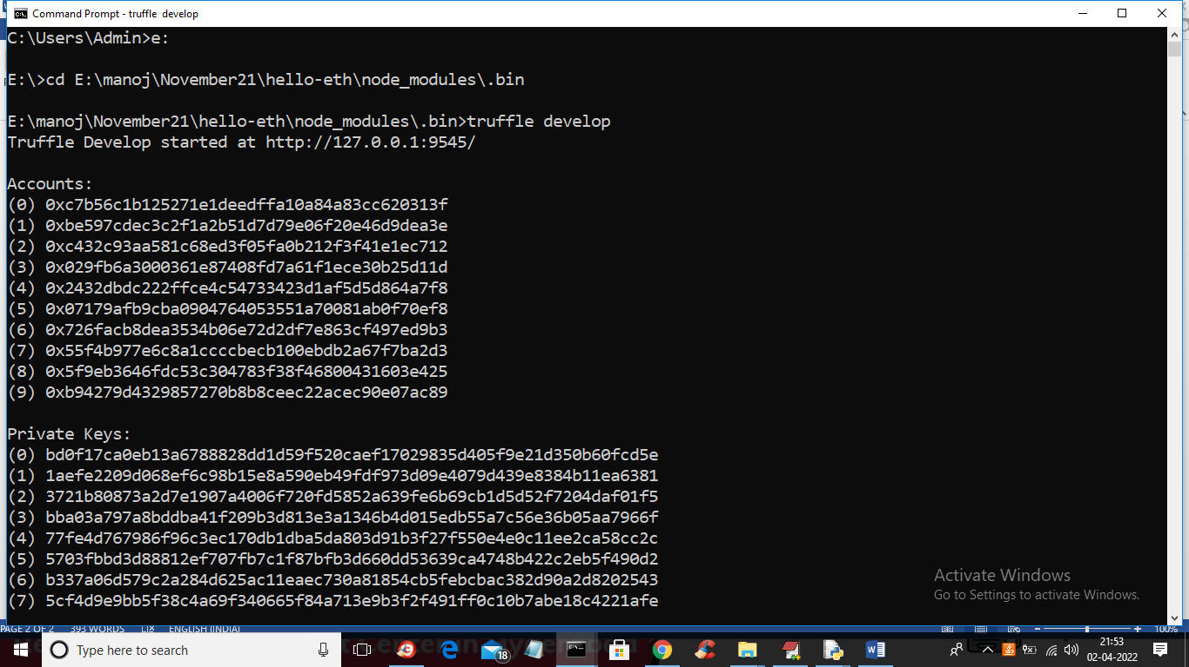
3. In above screen we can see Blockchain generated some default accounts and private keys and now type ‘truffle migrate’ and press enter key to deploy contract and to get below screen
4. 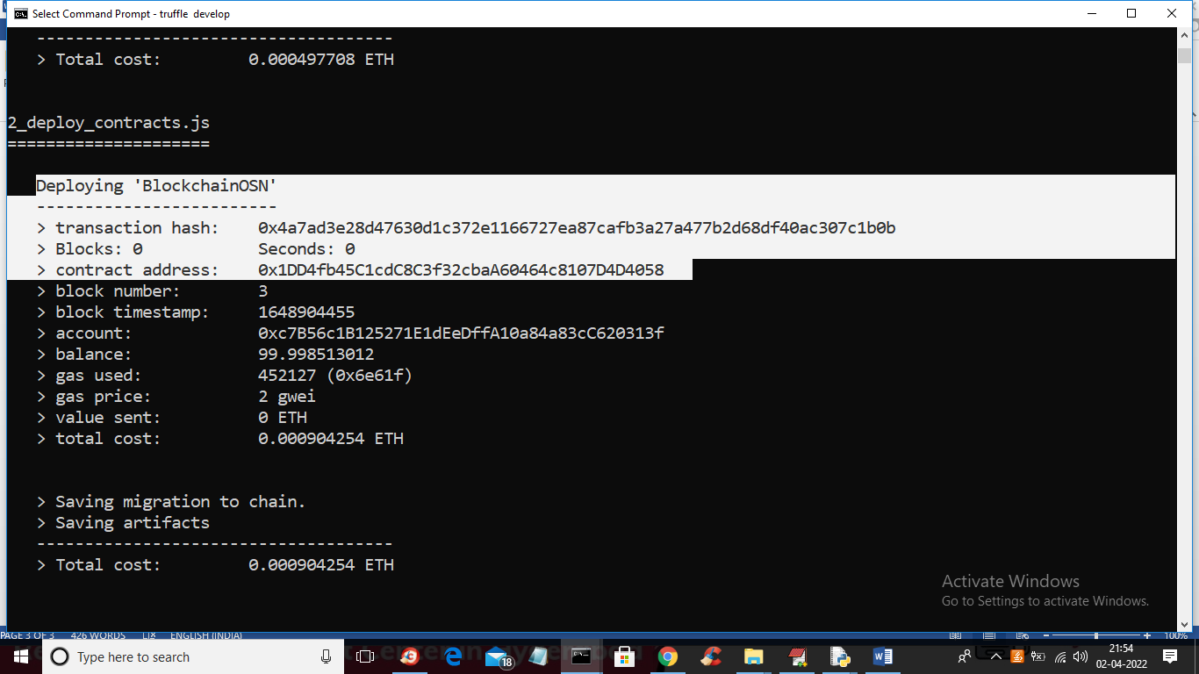
5. In above screen in white colour text we can see ‘BlockchainOSN’ contract deployed and we got contract address and this address will specify in python program to access that contract and below screen showing that python code
6. 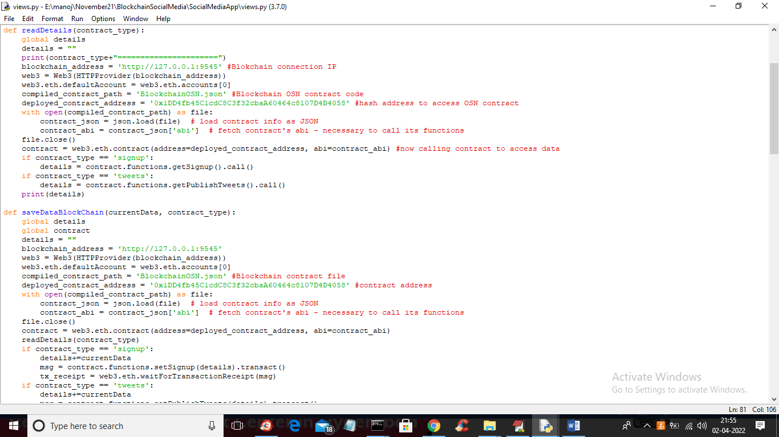
7. In above screen read red colour comments to know how to access Blockchain contract. Now contract is deployed and now double click on ‘Start_IPFS.bat’ file to start IPFS server which is used to store all publis post images as Blockchain cannot store images so we are using IPFS to store images
8. 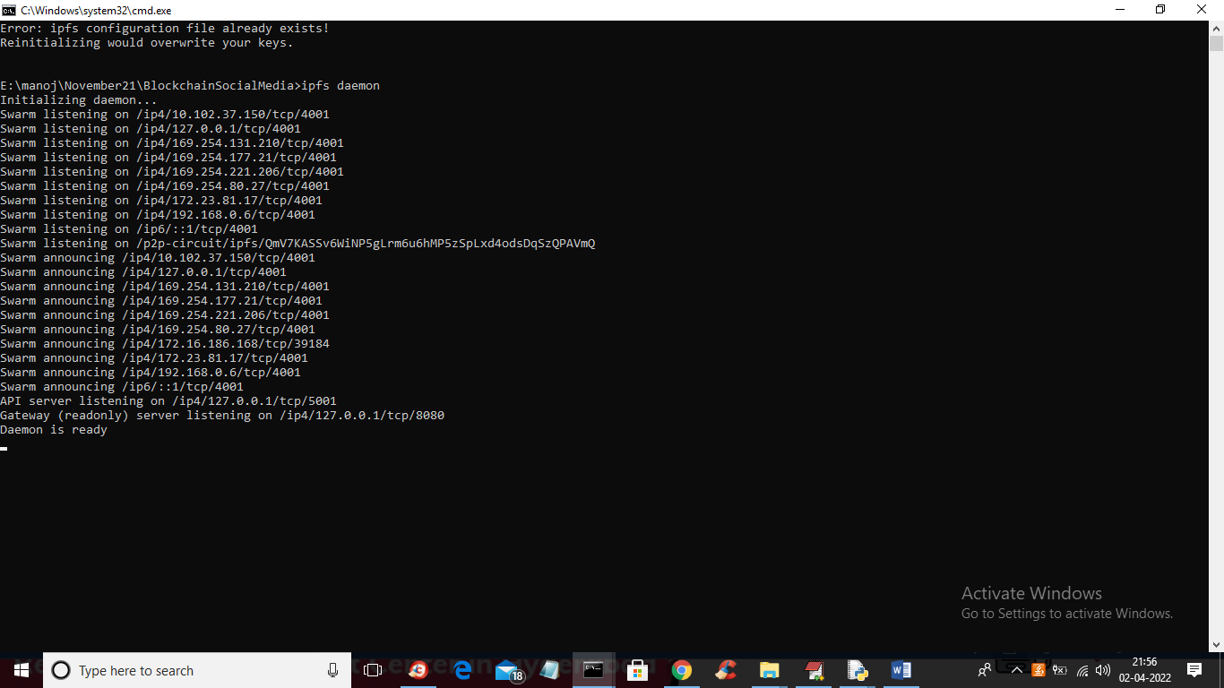
9. In above screen IPFS server is running and now double click on ‘runServer.bat’ to start python DJango webserver and get below output

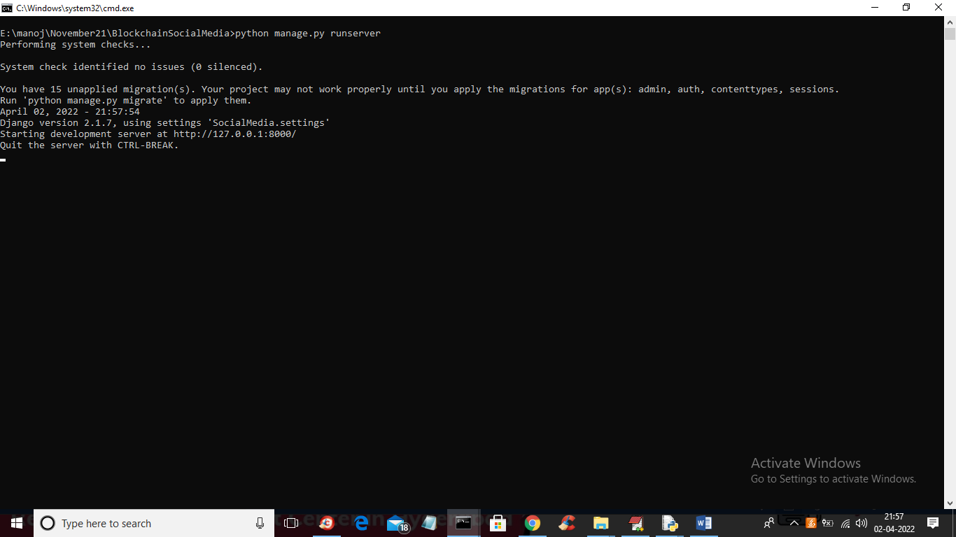

In above screen python server started and now open browser and enter URL as ‘http://127.0.0.1:8000/index.html’ and press enter key to get below output

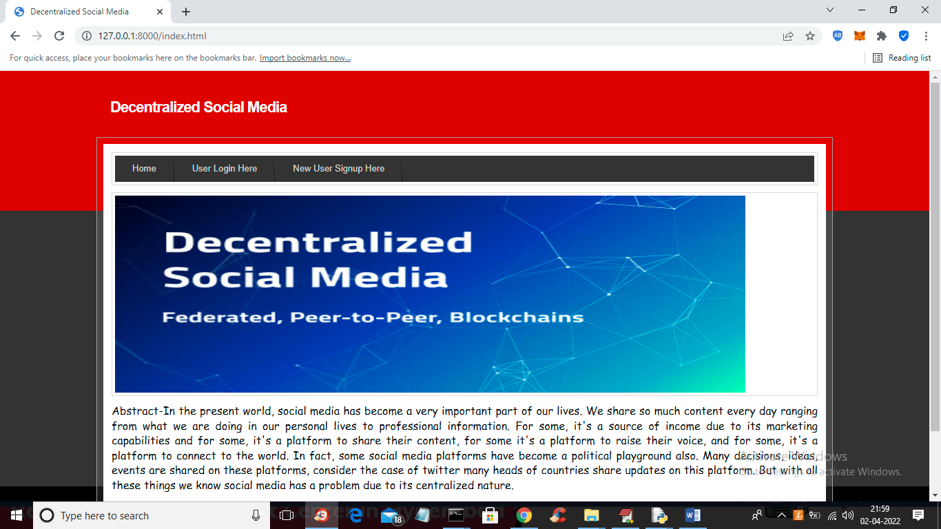

In above screen click on ‘New User Signup Here’ link to add new user

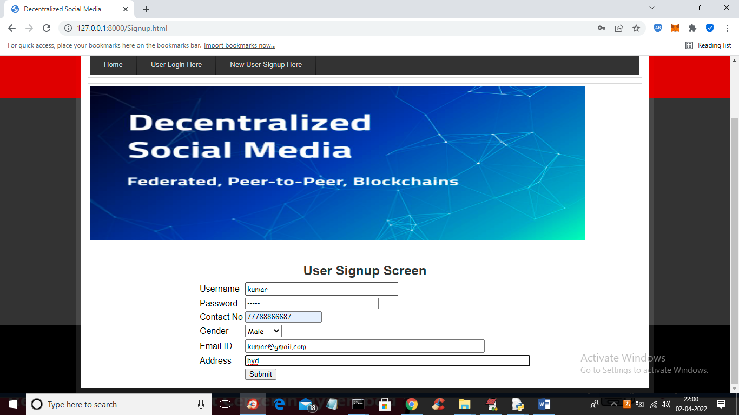

In above screen user is entering signup details and then press button to get below output

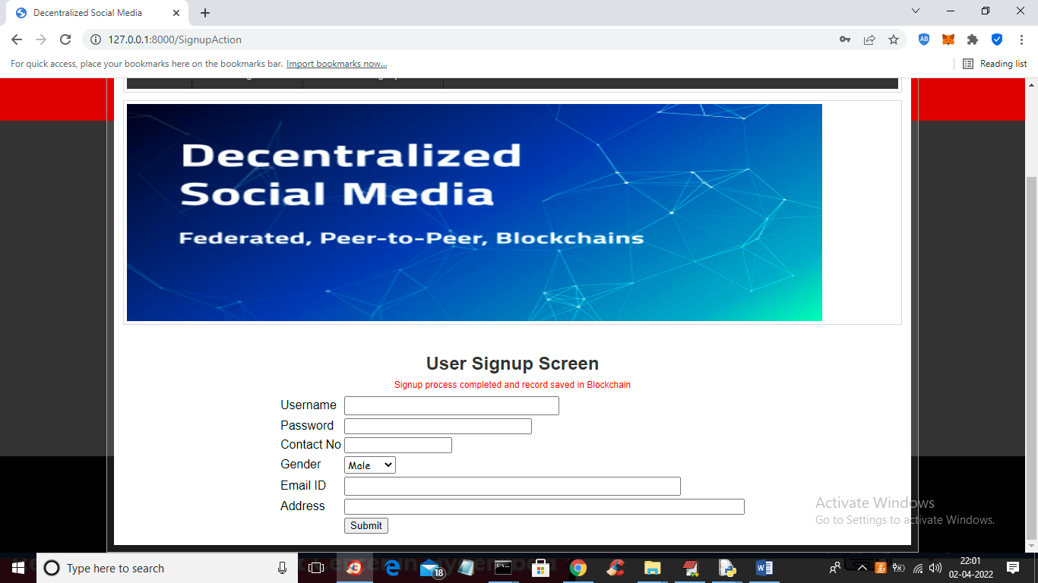

In above screen we can see user signup task completed and details saved in Blockchain Ethereum tool and now click on ‘Login’ link to get below screen

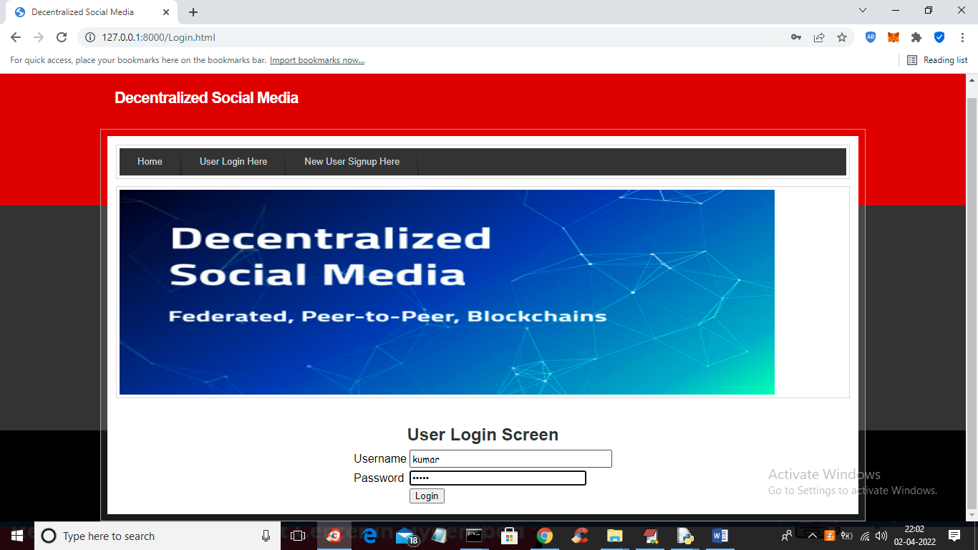

In above screen user is login and after login will get below screen

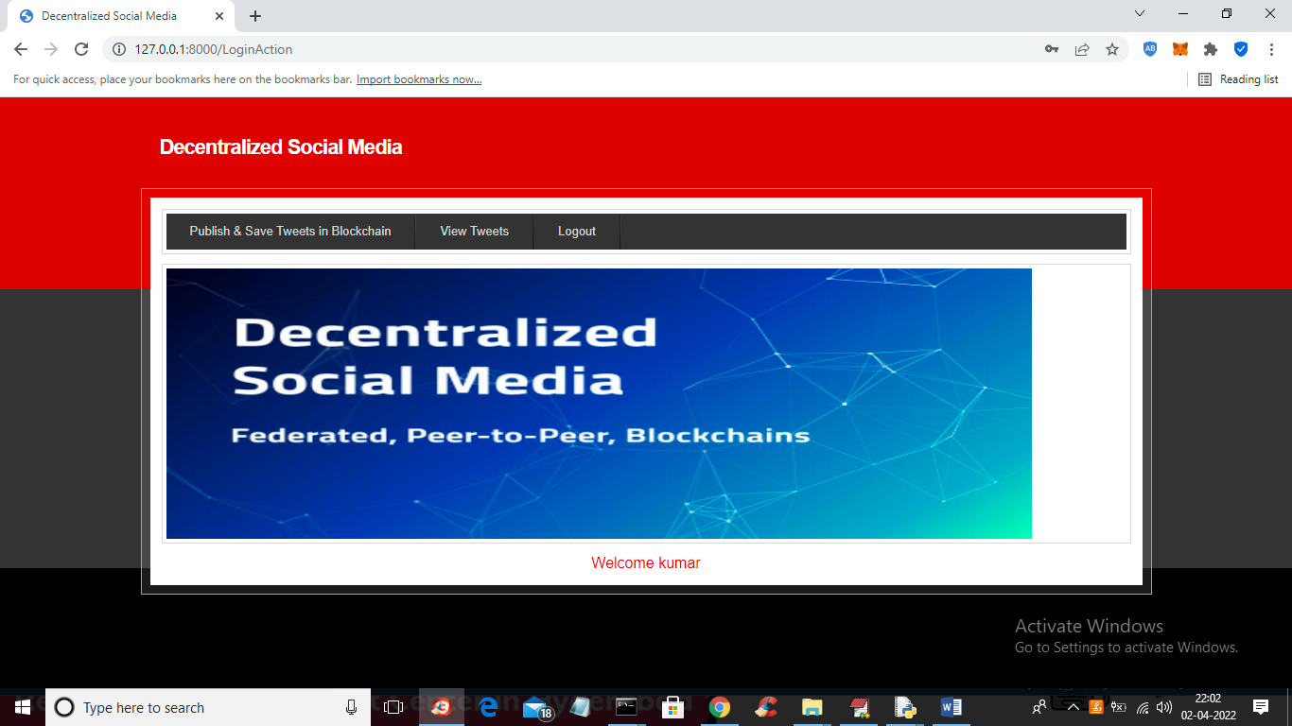

In above screen user can click on ‘Publish & Save Tweets in Blockchain’ link to post tweets

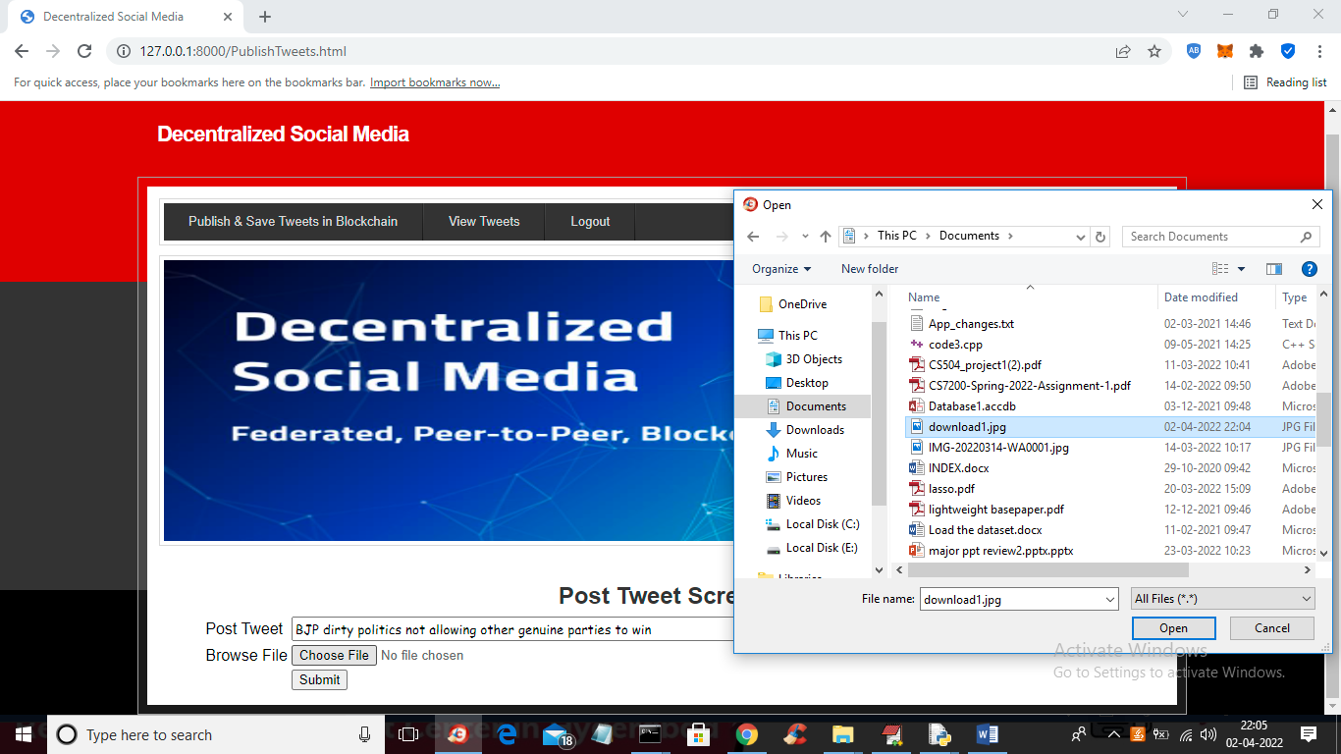

In above screen user can post any message and can upload related picture and then press button to save post in Blockchain

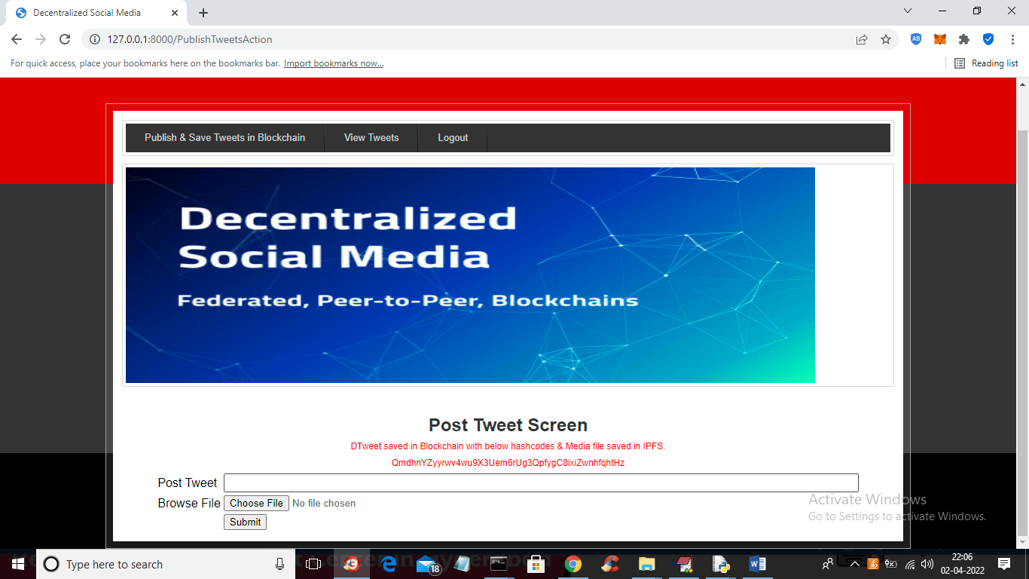

In above screen we can see post details is saved on Blockchain and we got its Hash code also where this post is stored in Blockchain and this post can be viewed by only other users who are registered with Blockchain and now click on ‘View Tweets’ link to view messages

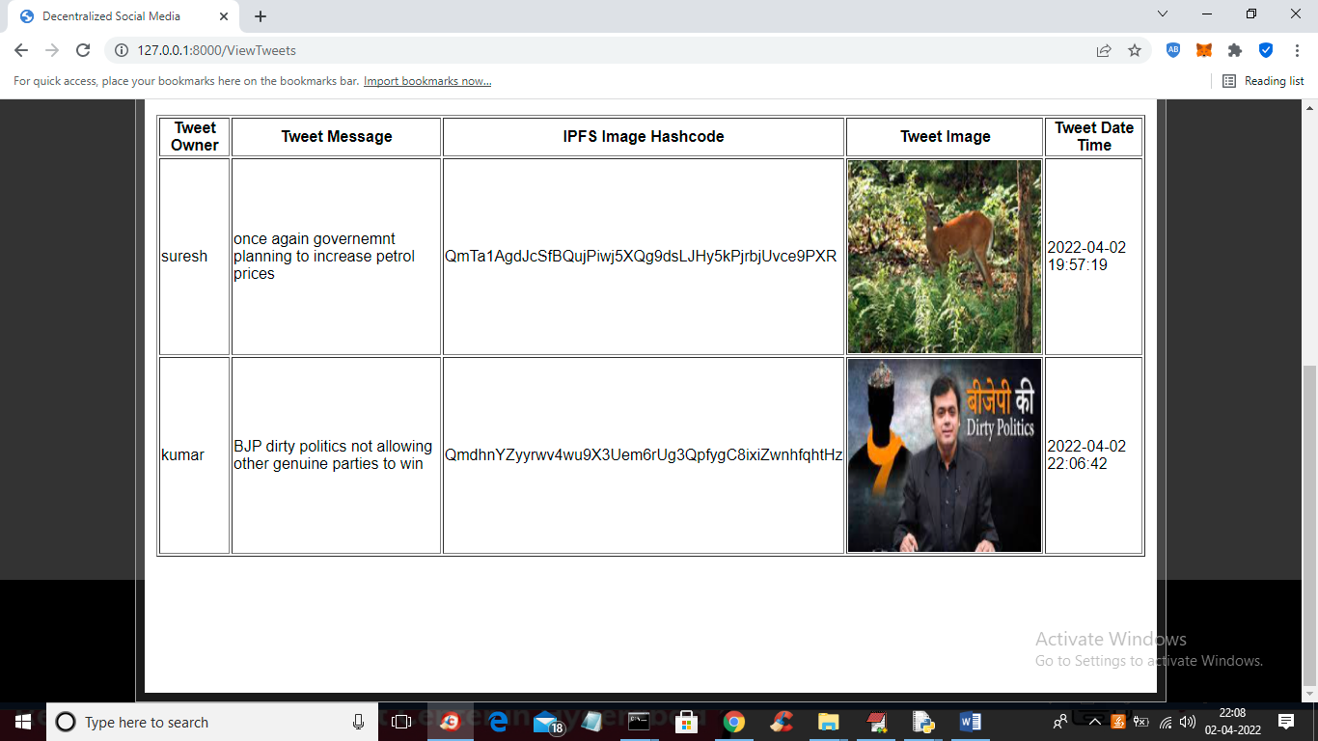

In above screen all users can view tweets publish by him and other users and similarly any number of users can signup, login and can view or post tweets.